Instructions for the abstract preparation for “RubberCon 2018”, Istanbul, Turkey
Nurseli UYANIK¹, Ali DURMUS², Serkan EMIK²
¹ Istanbul Technical University, Faculty of Science and Art, Department of Chemistry, Ayazağa, Istanbul, TR.
² Istanbul University, Engineering Faculty, Department of Chemical Engineering, 34320, Avcılar, Istanbul, TR.
e-mail address of the presenting author (uyanik@itu.edu.tr)

Keywords: A maximum of 4 keywords; separated by semicolons (Times New Roman 11 pt, single-line spacing, left-aligned text).

All abstracts should be formatted using either the template provided or according to the following guidelines and must be submitted via e-mail to “info@rubbercon2018.org”. The abstract, written in English, should be no longer than 2 pages as MS-word document (A4 size). Times New Roman font in 12 pt size and single line spacing should be used throughout the document. Abstract title must be in 14 pt size and bold (typed in lower case and centered) and should be as concise as possible.

Full names of authors should be given and separated by commas. The presenting author must be underlined and his/her e-mail address must be given. Affiliations should follow on the next line with a blank line. Affiliations should be centered. Superscript numbers should be used as a key to affiliate names to organizations. Numbers should appear after the names of authors and then before each affiliation. Leave a blank line before and after the keywords. Keywords should not be more than 4 and separated by commas. Leave a blank line before the main abstract text. Do not type "abstract" at the start of the main text.

Left, right and lower page margins should be set at 2.0 cm each whereas the upper page margin should be set at 1.5 cm. Justify paragraphs and indent the first line. Inclusion of embedded Figures and Tables formatted like the given examples below is accepted. Please note that the total file size should not exceed 1 MB.

Please avoid too long introduction and general information and instead, provide the specific purposes of the work. The abstract should clearly describe the main motivation and goal of the study by also comparing to the previous works. References should be given in square bracket [1-3] throughout the document and properly listed at the end of abstract according to the given format.

It is expected that the abstract consists of results shortly and conclusions briefly.

Figure 1. Chemical structure of dicumyl peroxide

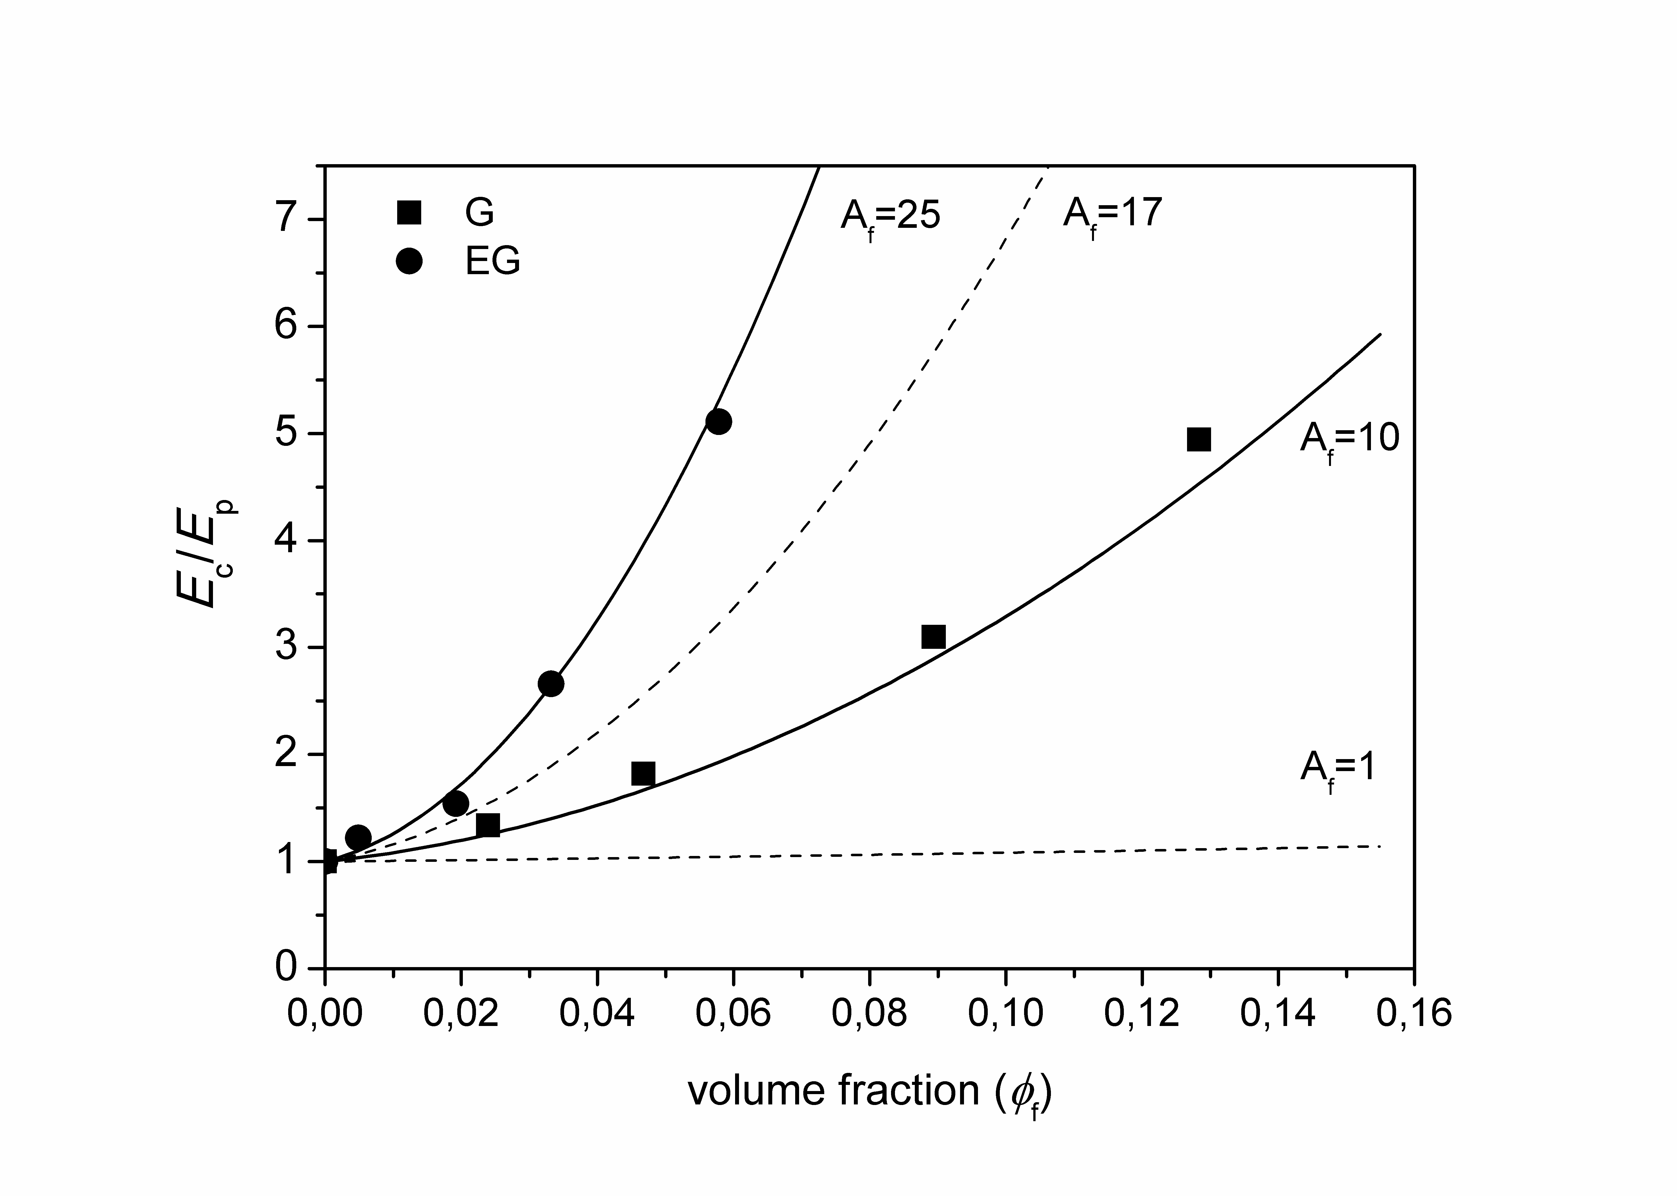
Figure 2. Modeling of elastic modulus by the modified-XYZ equation

Table 1. Sample compositions
Components [phr] | Sample notations
Components [phr] | N1 | N2 | N3 | N4 | N5
NBRª | 100 | 100 | 100 | 100 | 100
Carbon black | A | A | A | A | A
ZnO | B | B | B | B | B
Stearic acid | C | C | C | C | C
Antioxidant | D | D | D | D | D
Plasticizer | E | E | E | E | E
Co-agent | F | F | F | F | F
DCP^{b} | X | Y | Z | W | Q
ª Nitril-butadien rubber
^{b} Dicumyl peroxide

Acknowledgement
Thanks to the grant sponsors and/or people who contribute to the study

References
1. Karaağaç B., Turan H.O., Oral D.C., Journal of Elastomers and Plastics, 2013; 13: 3451.
2.

